MaxYoung |  | Beijing China | 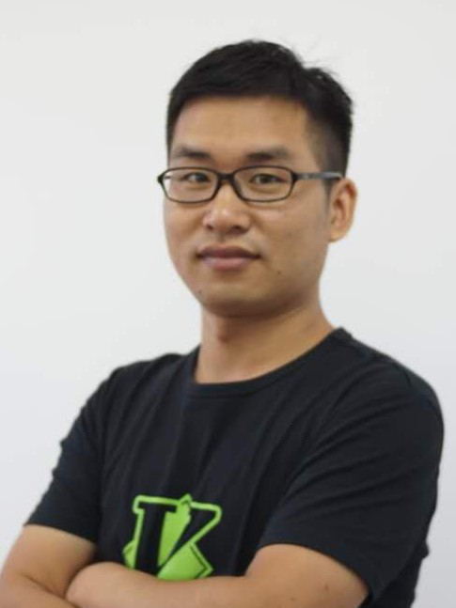
 |  | +86 186 0103 6905
 |  | alvysurvey@gmail.com
Full-Stack Engineer
 |  | https://maxyoung.fun/
Skills
Web Full-stack development from frontend to backend, including testing, optimization, de-Application ployment, and maintenance. Proficient in Python, React, HTML/CSS, Shell, MySQL, MongoDB, etc. Strong product sense and user-first thinking; able to turn ideas into smooth, scalable experiences. Team player with solid agile development experience.
Mobile App Published an App named on Google Play. Skilled in building cross-platform apps with React Native, focusing on performance and user experience.
DevOps Hands-on with Linux, Docker, Git, and CI/CD pipelines. Experienced in building reliable, automated deployment workflows.
Experience
2022-now Software Engineer, , Beijing, Autonomous Driving
Vehicle Calibration Software Python, Shell, C++, OpenCV
Independently developed from scratch, revolutionizing the process by automating operations and reducing communication costs.
- Enhanced factory calibration for hundreds of new vehicles, increasing daily throughput from 2-3 to 10+ vehicles.
- Streamlined field calibration, reducing on-site time from 0.5-1 day to under 0.5 hours.
OTA Version Management System Python(Flask), Next.js, RabbitMQ
Independently developed an OTA system, enabling efficient autonomous driving software up-dates.
- Automated software/map deployment, reducing average download time for hundreds of vehicles from hours to under 0.5 hours with near-zero errors.
- Modernized vehicle/series/version management with a user-friendly system.
Kanban Project Management System Python(Flask), React, Ant Design
Independently developed a Kanban-based project management system for autonomous driving.
- Improved accident management, contributing to a reduction in the accident rate from 13 to 7 per 10,000 kilometers within six months.
- Facilitated efficient delivery of dozens of new routes.
- Enhanced team collaboration by bridging the communication gap between R&D and op- erations.
Summary of Contributions: Independently developed these projects, overcoming technical challenges across various domains. Demonstrated leadership in product design, project coordi-nation, and communication between technical and operational teams.

2017-2022 Software Engineer, , Beijing, Online Education
Designed and implemented comprehensive e-commerce systems including inventory manage-ment, order processing, and distribution workflows. Engineered automated order integration with major platforms (JD.com, Taobao), significantly enhancing business operations efficiency.
Python(Django), Go(gin)
Developed the financial system. Including financial recognition, financial settlement, data analysis, etc. Established financial office automation and improved financial work efficiency.
Python(Flask)
Championed Test-Driven Development (TDD) and contract testing methodologies, substan- tially reducing bugs and enhancing development efficiency across teams.
2014-2017 Software Engineer, , Beijing, Exam SAAS Provider
Architected and developed a comprehensive online examination platform from conception to pro-duction, handling full-stack development, DevOps implementation, and team leadership. Success-fully scaled the system to serve thousands enterprise customers. Python(Flask).
2013-2014 Map Quality Engineer, , Beijing, Mapping Services Provider
Conducted in-depth analysis of geospatial POI and road network data, established standardized quality control protocols for map assets, and delivered strategic recommendations for data collec-tion planning and quality metrics implementation.
2006-2013 Geomatics Engineer, , Beijing, Hydropower En- gineering
Contributed to geospatial surveying and technical design for multiple large-scale hydropower in-frastructure projects, applying precision engineering methodologies in diverse geographical envi-ronments.
Education
2002-2006 Geomatics Bachelor, , Nanjing, China
Hobbies
Languages English (Academic IELTS 6.5) Japanese (N2 Level)
Sport Certified Beijing Marathon Runner (Third-Level Athletic Certification)

